**Step 1**: Create a custom error response class

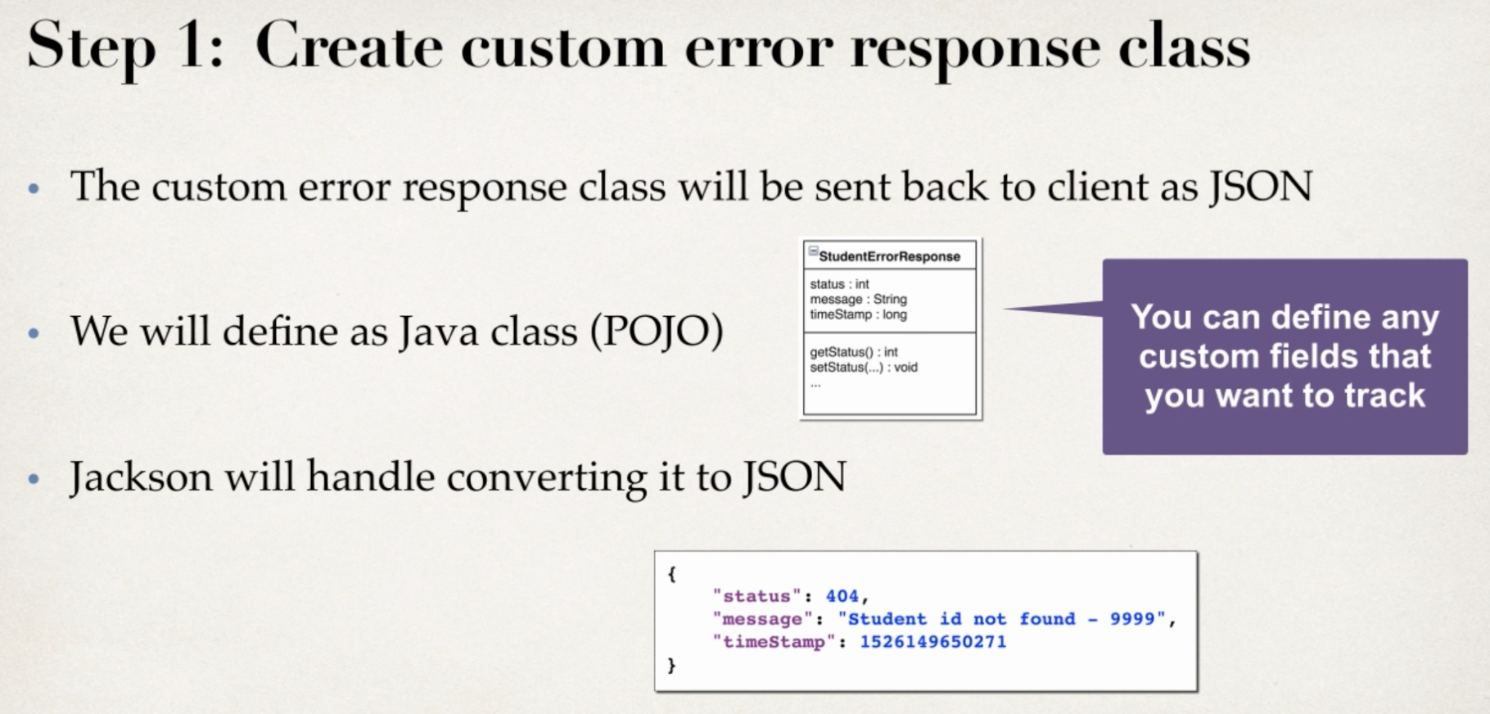

**Step 2**: Create a custom exception class

If we can’t find student, we throw this exception

**Step 3**: Update REST service to throw exception if student not found

**Step 4**: Add an exception handler method using @ExceptionHandler

